**Mastering Multi-Cloud**

**Labs: Multi-Cloud Governance, Monitoring, and Cost Management**

**Lab 01: Azure Policy**

**Case Study**

BP is a global energy company operating across multiple regions, supporting exploration, production, refining, and digital innovation at scale. As part of its digital transformation journey, BP adopted Microsoft Azure to modernize its IT infrastructure, improve operational efficiency, and support data-driven decision-making across business units.

With hundreds of teams deploying cloud resources independently, BP manages a highly complex Azure environment consisting of multiple subscriptions, resource groups, and workloads. To maintain visibility, security, and cost accountability across this environment, BP requires a centralized governance mechanism that ensures Azure resources are deployed in a consistent and compliant manner without slowing down innovation.

Azure Policy plays a critical role in BP’s cloud governance strategy by enabling automated enforcement of organizational standards, ensuring that every resource aligns with security, compliance, and operational requirements.

**Business Challenge**

As Azure adoption expanded rapidly, BP faced increasing governance challenges. Teams provisioned resources without consistent tagging, deployed services in unauthorized regions, and created resources that did not meet internal compliance standards. Manual governance processes were time-consuming, error-prone, and difficult to scale across hundreds of subscriptions.

BP needed a solution that could automatically enforce governance controls, provide visibility into resource usage, and ensure compliance across all Azure deployments. The organization required a centralized approach that allowed governance rules to be applied consistently while still enabling development teams to work efficiently.

**Solution**

In this lab, Azure Policy is used to demonstrate how BP can enforce governance standards across its Azure environment. Azure Policy allows organizations to define rules that control how resources are created, tagged, and configured. These policies can audit existing resources, deny non-compliant deployments, or automatically remediate configuration issues.

By using Azure Policy, BP enforces mandatory resource tagging to track project ownership and usage. Policies are assigned at the subscription and resource group levels to ensure consistent enforcement. Automatic remediation ensures that resources created without required tags are updated automatically, reducing manual effort and improving governance visibility. Azure Policy enables BP to achieve scalable cloud governance, stronger compliance, and improved operational control across its Azure infrastructure.

Assume you have been recruited as a cloud administrator at BP. The CTO wants visibility into which Azure resources are being used for a new infrastructure project. Your tasks in this lab are to:

* Create a way to tag the project resources
* Do not allow resources to be created without the resource tag
* If a resource is created without the tag, automatically add the tag

**Architecture Diagram**

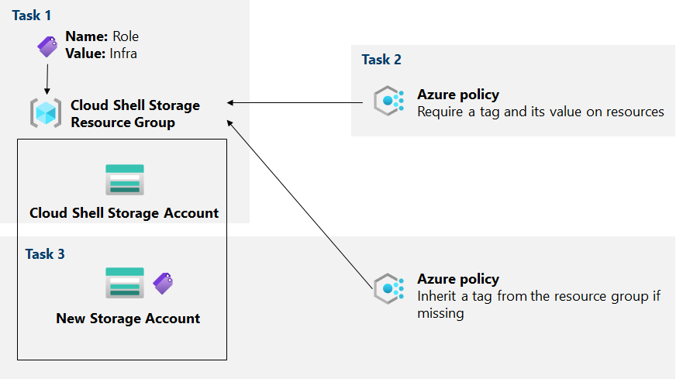

*Figure 6-02: Lab Diagram*

**Task 1: Assign tags via the Azure Portal**

|  |
| --- |
| 1. In the Azure portal, start a **PowerShell** session within the **Cloud Shell**.      1. From the Cloud Shell, run the command:      1. In the output of the command, note the first part.      1. In the Azure portal, search and select **Storage** accounts and, in the list of storage accounts, click the **entry** representing the storage account you identified in the previous step.      1. On the storage account blade, click the **link**.      1. To create new tags, click **edit** next to **Tags**.      1. Form a tag with the following settings and apply your change: |

**Task 2: Enforce tagging via an Azure policy**

|  |
| --- |
| 1. In the Azure portal, search for and select **Policy**.      1. On the Require a tag and its value on the resources built-in policy definition blade, click **Assign**.      1. Specify the scope by clicking the ellipsis button and selecting the following values:      1. Configure the **Basics** properties.      1. Click **Next** and review the **Remediation** tab.      1. Click **Review + Create** and then click **Create**. |

**Task 3: Apply tagging via an Azure policy**

|  |
| --- |
| 1. In the Azure portal, search for and select **Policy**.     2. In the **Authoring** section, click **Assignments**.    3. In the list of assignments, click the **ellipsis** icon in the row representing the **Require Role** tag with the **Infra** value policy assignment. Use the **Delete assignment** menu item to delete the assignment.    4. Click **Assign** policy and specify the scope by clicking the **ellipsis** button and selecting the following values:    5. Configure the remaining **Basics** properties.    6. Click **Next** and, on the **Remediation** tab, configure the following settings:    7. Click **Review + Create** and then click **Create**.    8. Go back to the blade of the resource group.    9. On the resource group blade, click **+ Create** and then search for **Storage Account**, and click **+ Create**.    10. Verify that you are using the **Resource Group** to which the **Policy** was applied.    11. You will see that this time the validation passed. Click **Create**.    12. Once the new storage account has been created, click the **Go to resource** button. On the **Overview** blade of the account, you will see that the resource has been given the tag **Role** with the value **Infra** by default. |

**Lab 02: Creation of CloudWatch**

### **Case Study**

Netflix is one of the world’s leading streaming entertainment companies, delivering video content to millions of users globally. To support its large-scale, highly distributed architecture, Netflix relies heavily on Amazon Web Services to run compute, storage, and application workloads across multiple regions. Ensuring high availability, performance, and reliability is critical, as even short service disruptions can impact customer experience and revenue.

To maintain operational excellence, Netflix requires continuous monitoring of its AWS infrastructure and applications. Amazon CloudWatch serves as a foundational management and governance service that enables Netflix to observe system behavior, monitor performance metrics, analyze logs, and respond to operational events in real-time.

### **Business Challenge**

Operating at a global scale, Netflix generates massive volumes of operational data across EC2 instances, load balancers, databases, and serverless services. Without centralized monitoring, identifying performance degradation, resource exhaustion, or application errors would be difficult and slow. Manual monitoring methods do not scale and often lead to delayed incident detection and longer recovery times.

Netflix needed a unified monitoring solution that could provide real-time visibility into system metrics, trigger alerts when thresholds are breached, and capture logs for troubleshooting and analysis. The organization required a native AWS service that integrates seamlessly with its cloud environment while supporting automated governance and operational monitoring.

### **Solution**

In this lab, Amazon CloudWatch is used to demonstrate how organizations like Netflix can monitor and govern their AWS environments effectively. CloudWatch collects metrics, logs, and events from AWS resources and presents them through dashboards for centralized visibility. Alarms are configured to monitor critical metrics such as CPU utilization and trigger notifications when predefined thresholds are exceeded.

CloudWatch Logs captures application and system logs, enabling faster troubleshooting and root cause analysis. By using CloudWatch dashboards and alarms, Netflix can proactively detect issues, improve system reliability, and reduce operational overhead. This approach allows Netflix to maintain high availability, enforce operational best practices, and ensure that AWS resources are performing as expected.

This lab covers the following tasks:

1. Log in to AWS Management Console.
2. Go to **Services**.

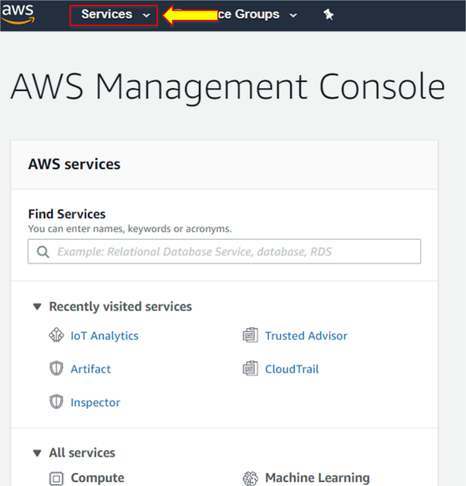

1. Click on **EC2**, the very first service under **Compute**.

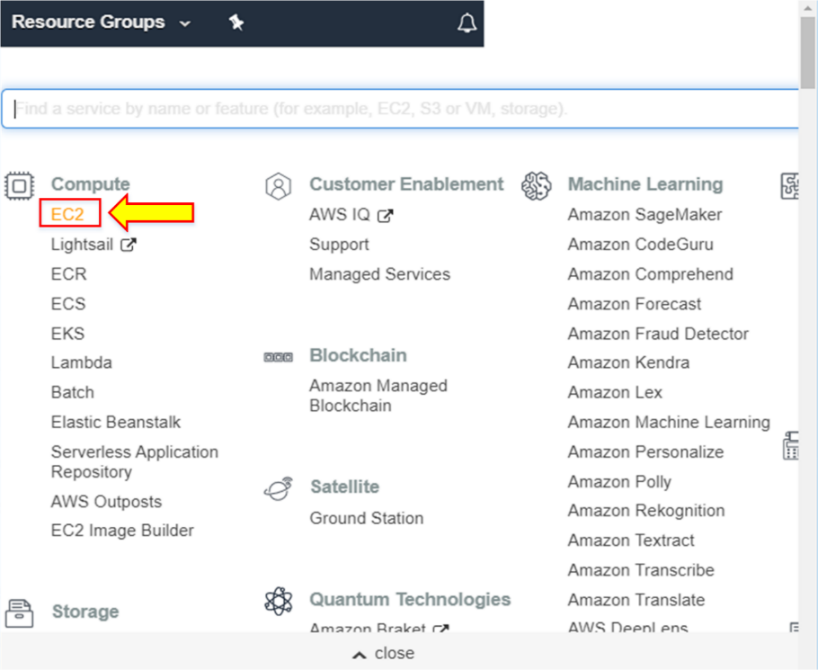

1. On the EC2 dashboard, click on **Launch Instance**.

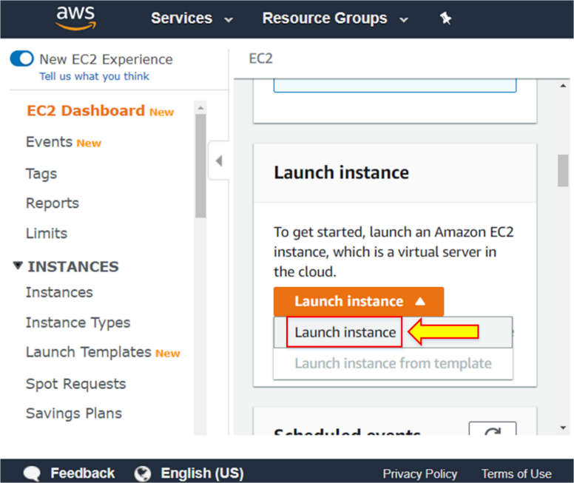

1. Step 1 is to choose an Amazon Machine Image (AMI).
2. Take **Amazon Linux 2 AMI (free tier eligible)** from the given options and click on **Select**.

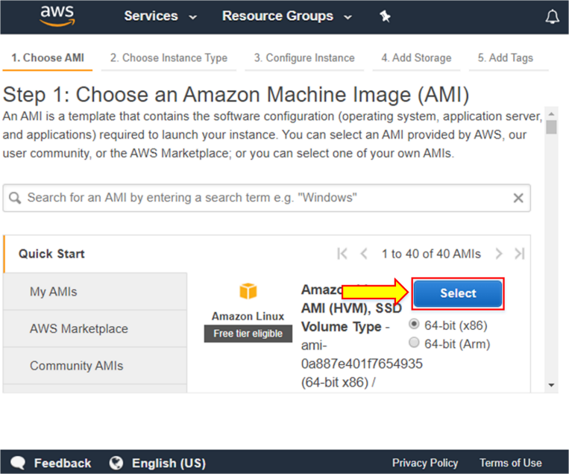

1. Step-2 is to choose an **Instance Type**. You have various instance types available, including general-purpose, memory-optimized, micro-instance, compute-optimized, etc. Select **General purpose** instance type with size **t2.micro** (Free tier eligible).
2. After selecting an instance type, click on **Next: Configure Instance Details**.

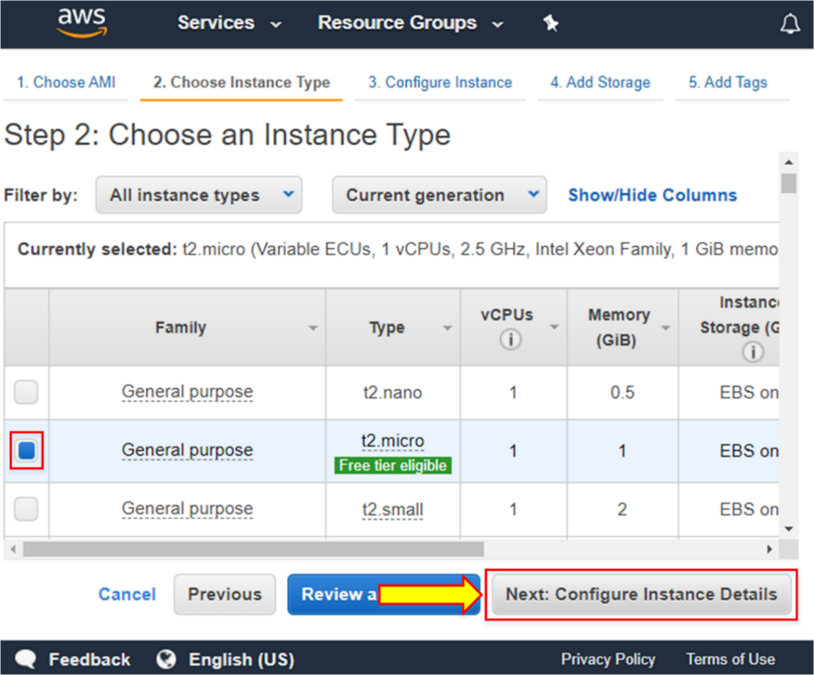

1. Tick the **Enable CloudWatch detailed monitoring**.
2. Click on **Next: Add Storage**.

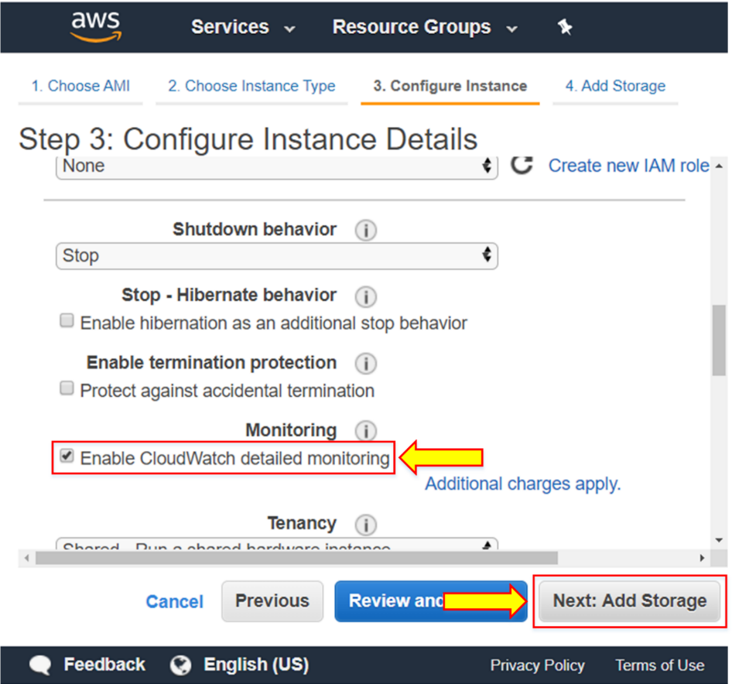

1. Click on **Next: Add Tags**.

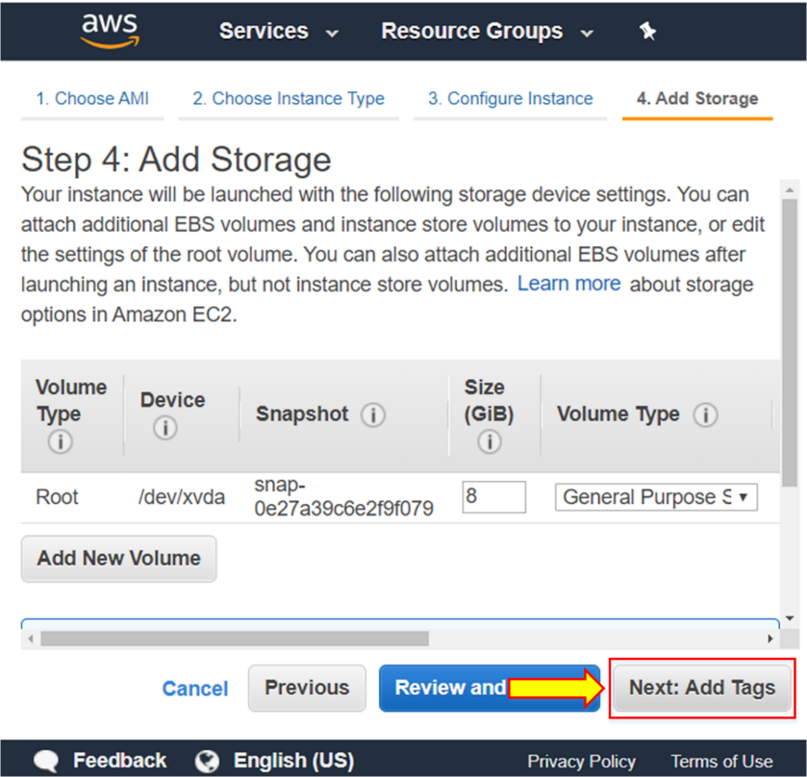

1. Click on **Add Tag**.

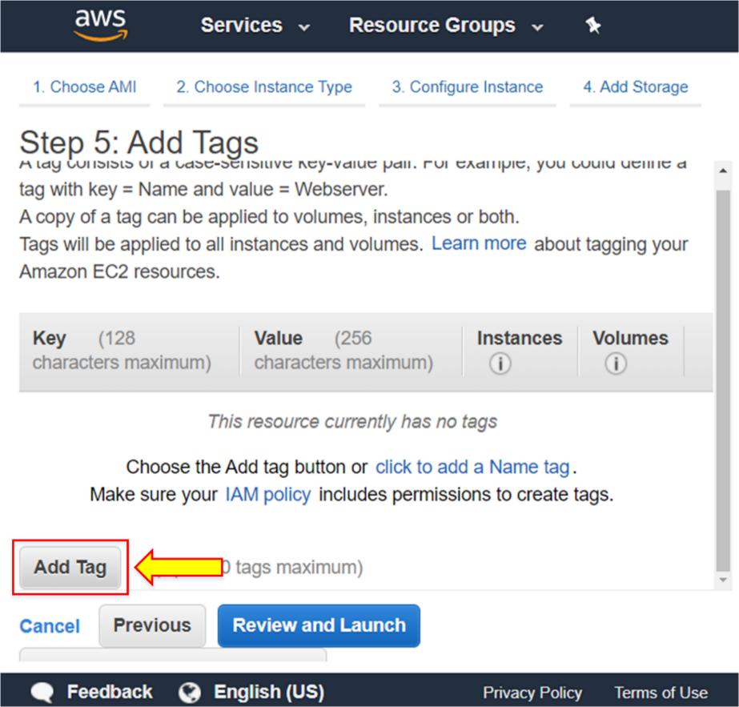

1. Write the key and value with **Name** and **IPSCloudWatch,** respectively.
2. Click on **Next: Configure Security Group**.

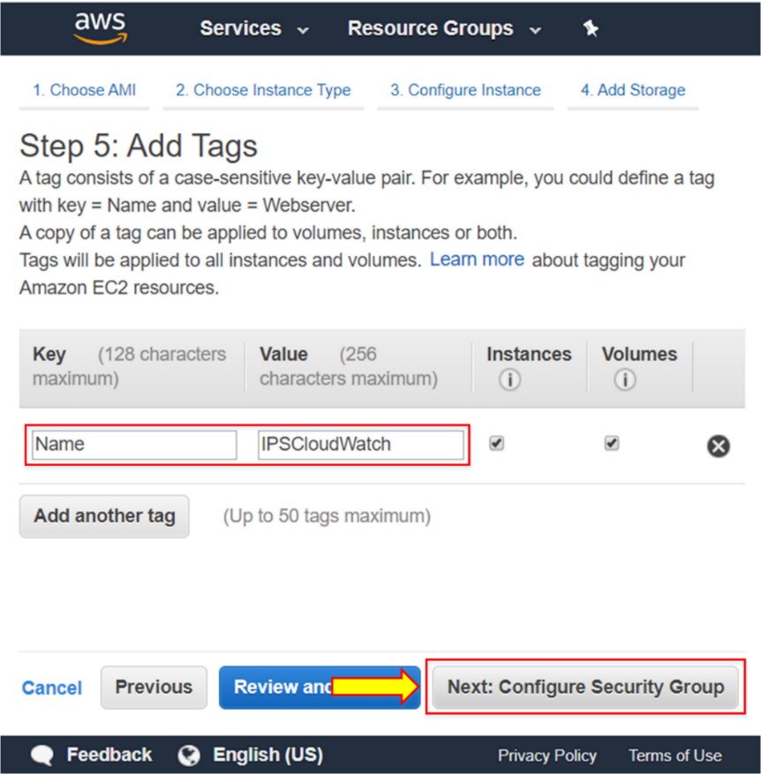

1. Click on **Select an existing security group**.

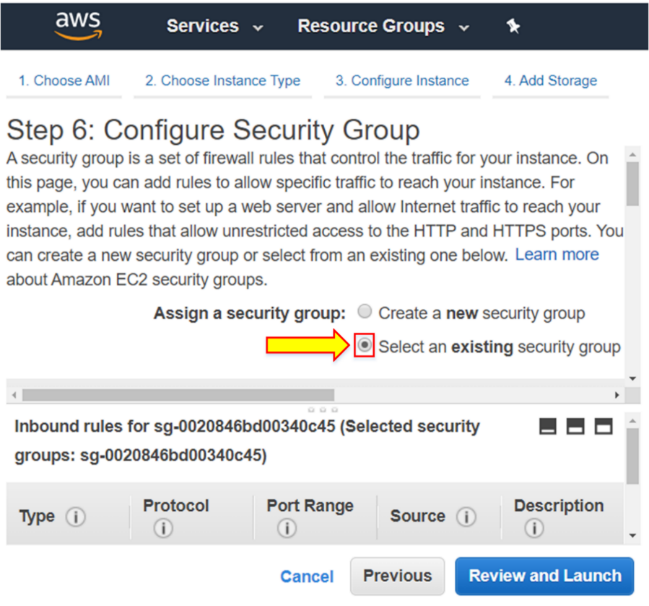

1. Select an existing security group, **Web_IPS_10**, from the list shown below.
2. Click on **Review and Launch**.

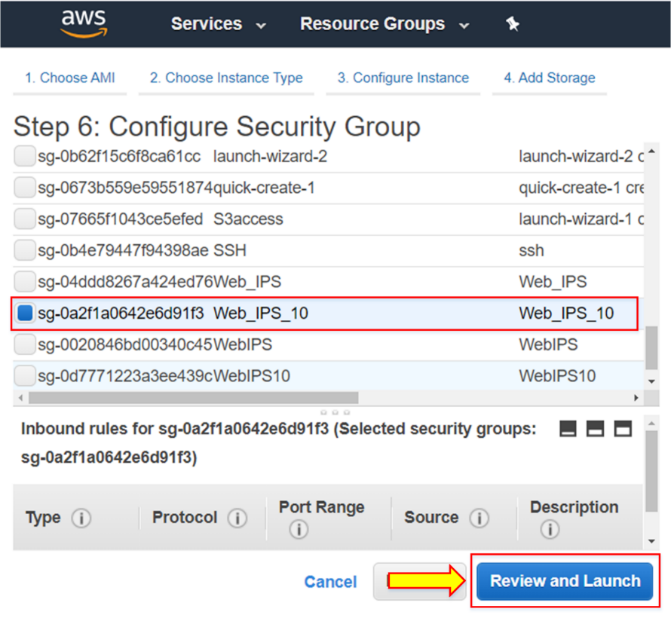

1. Click on **Launch**.

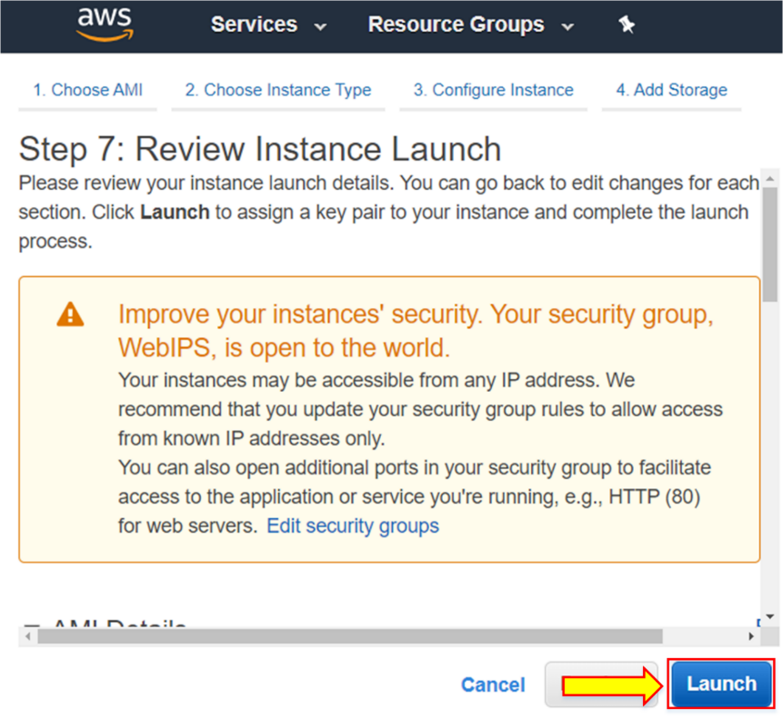

1. Choose an existing key pair and select **IPS_KP_10**.
2. Tick the acknowledgment.
3. Then, click on **Launch Instances**.

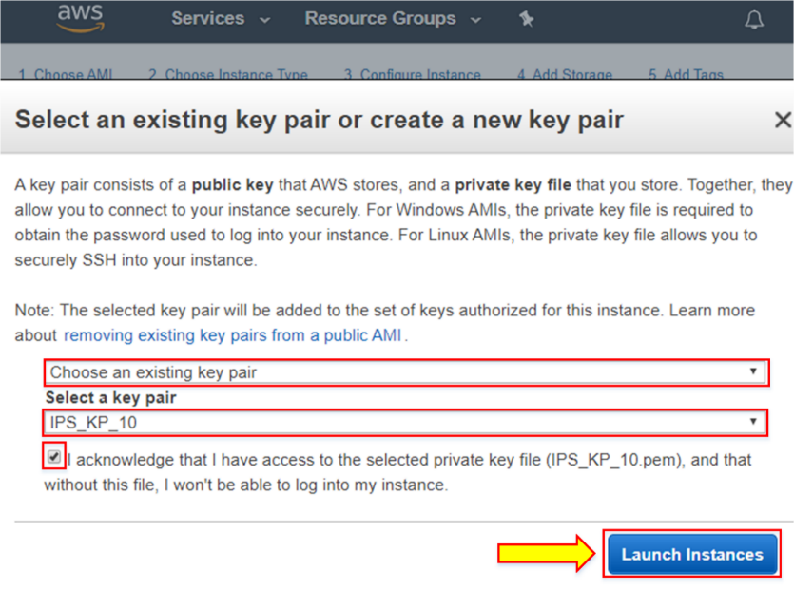

1. Click on **View Instances**.

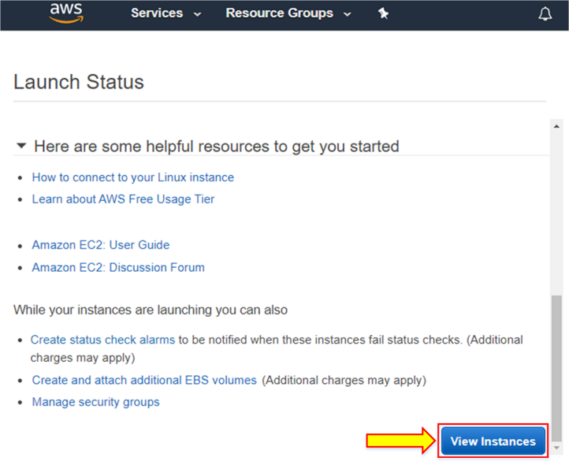

1. The newly launched instance is shown with the size of **t2.micro**.

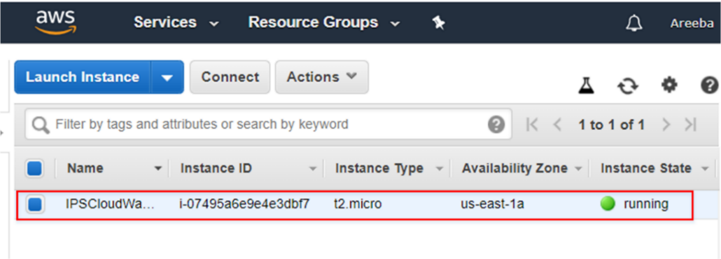

1. Click on **Status Checks** under Description.

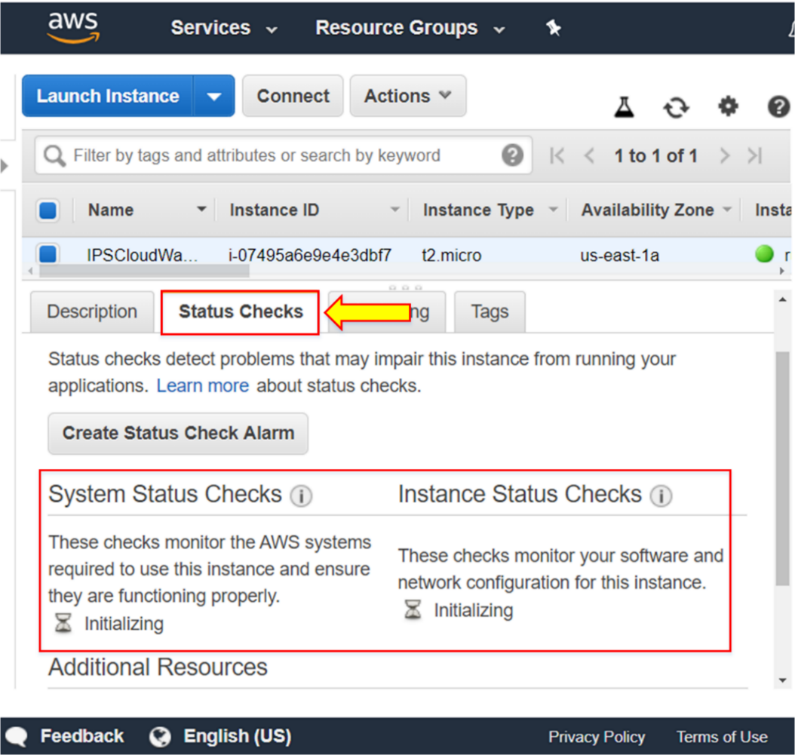

**Note:** Status Checks give information about system status checks and instance status checks.

1. Click on **Monitoring**.

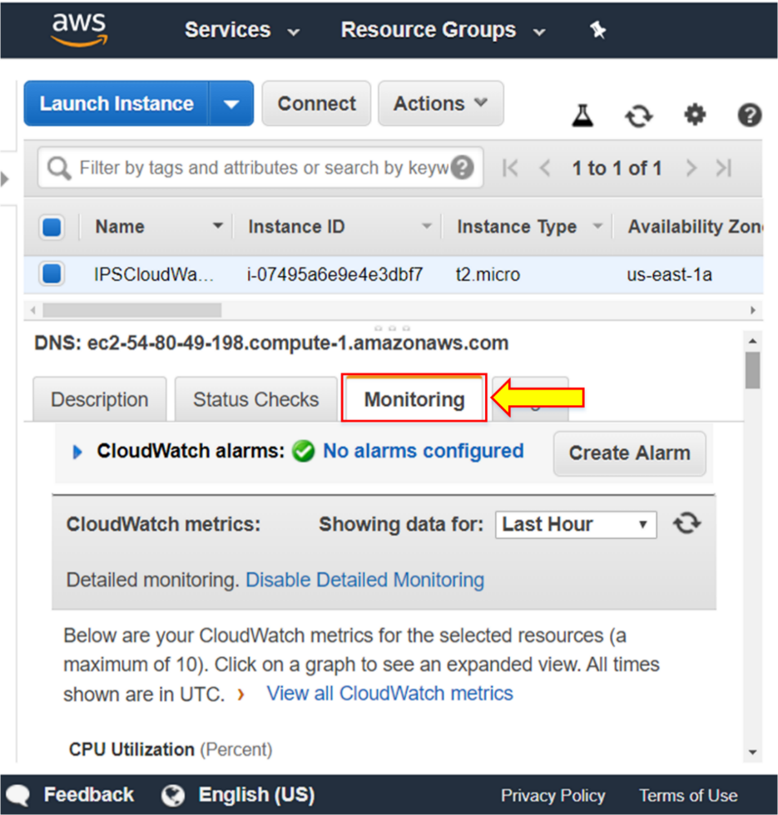

1. The monitoring tab gives the host-level metric information in terms of CPU utilization, Disk Read (Bytes), Disk Read Operations, Disk Write (Bytes), Network In (Bytes), etc.

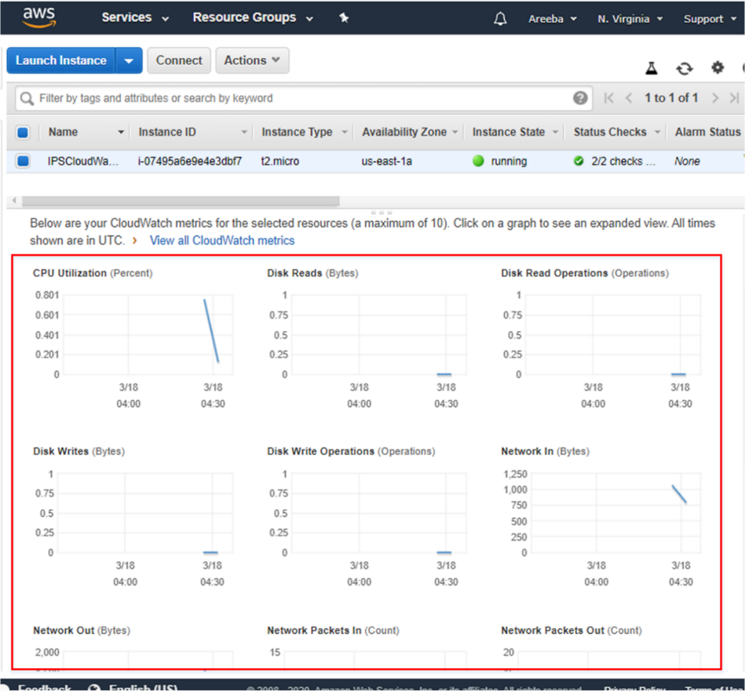

1. To set up alerts, go to the **Services**.

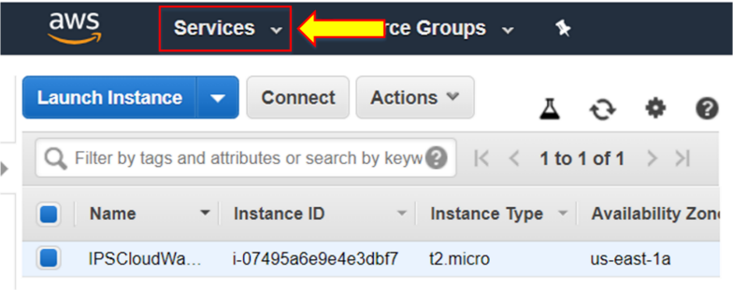

**Note:** Alerts can be needed when CPU Utilization is going above a certain percentage, for example.

1. Click on **CloudWatch** under Management and Governance.

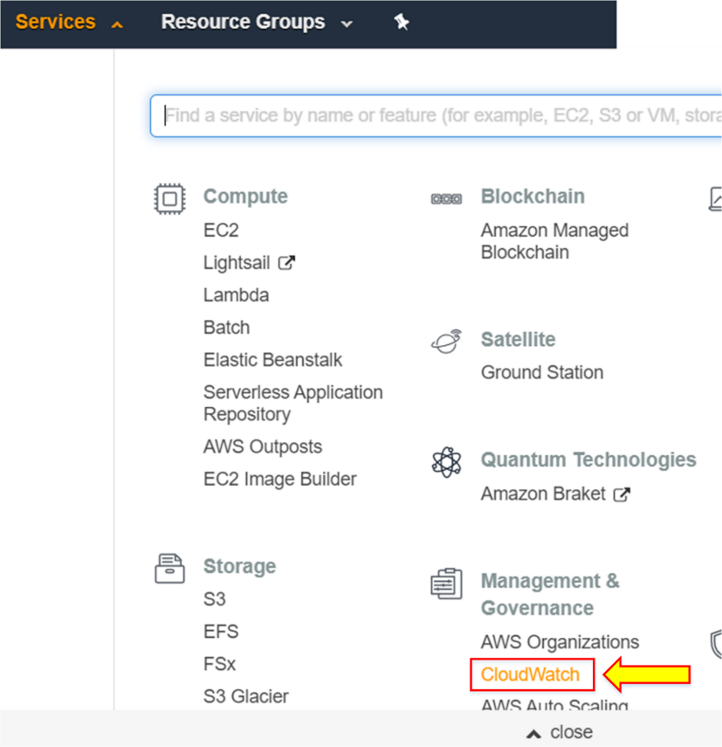

1. Click on **Alarms**, present on the left side menu.

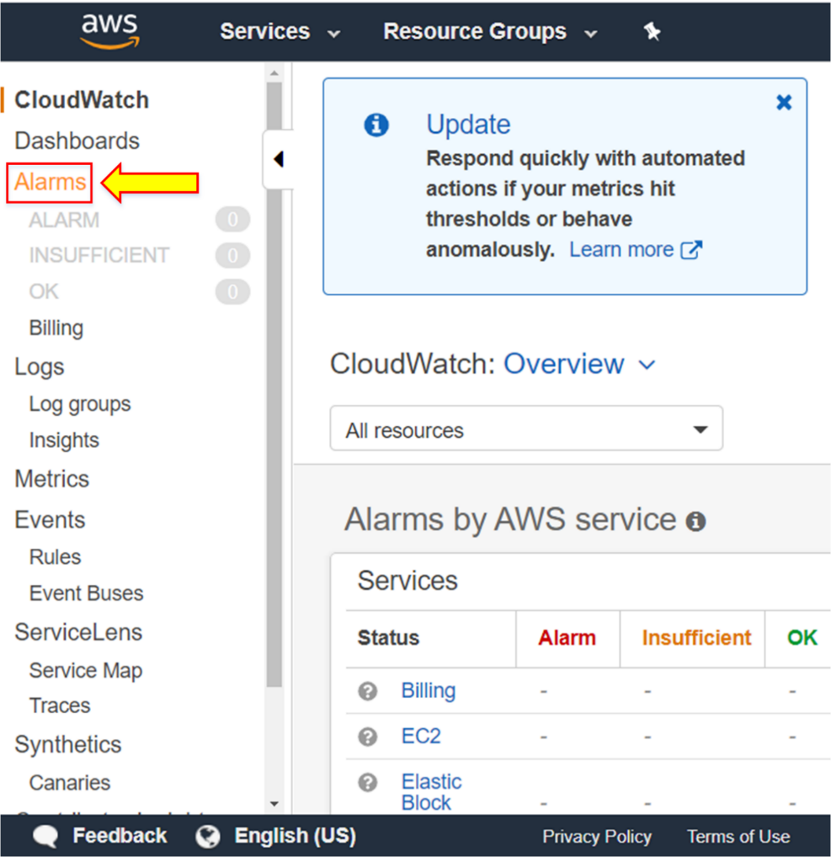

1. Click on **Create alarm**.

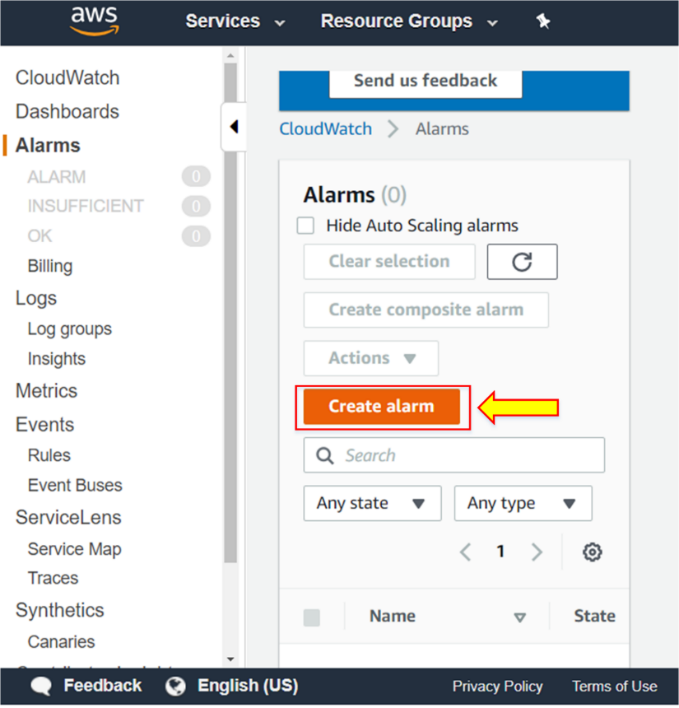

1. Click on **Select metric**.

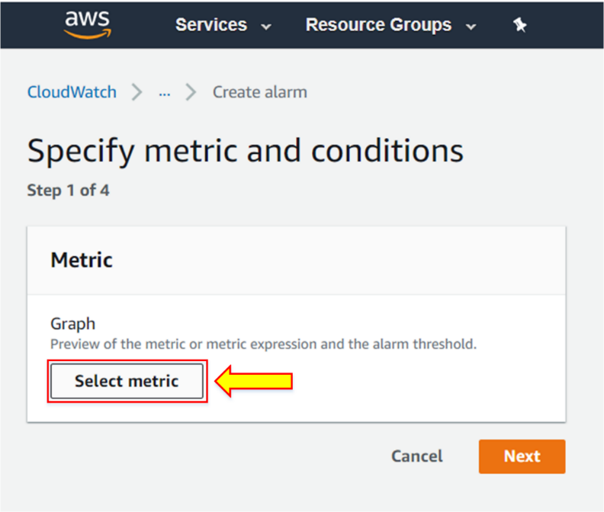

1. Select the **EC2** metric.

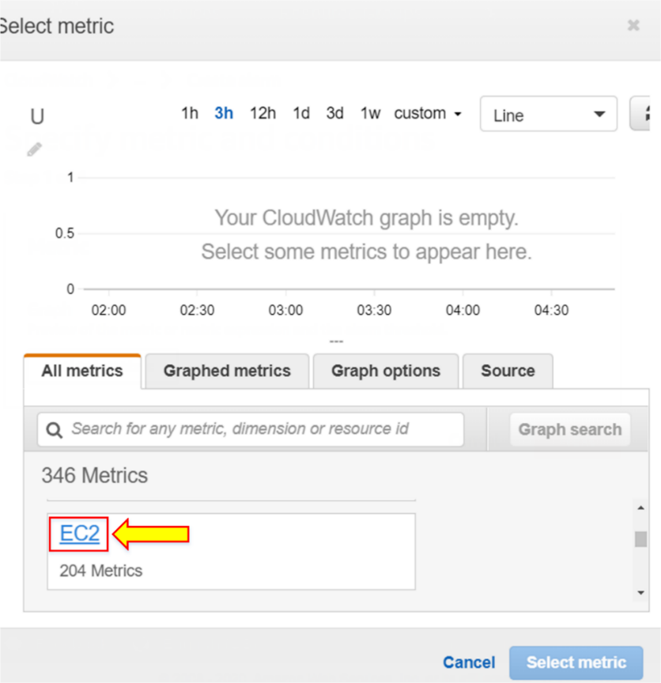

1. Click on **Per-Instance Metrics**.

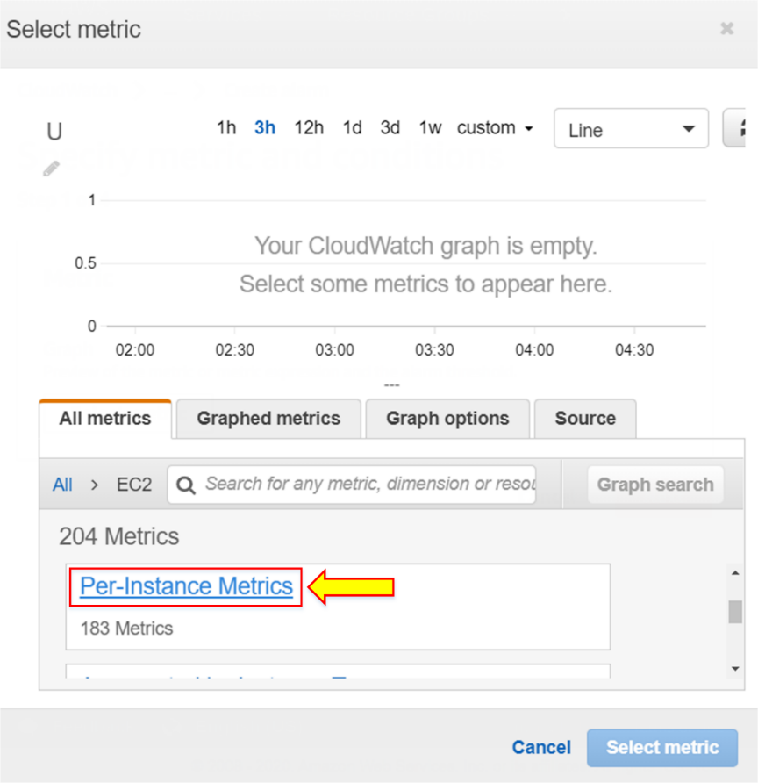

1. Select **IPSCloudWatch**, and click on **Select metric**.

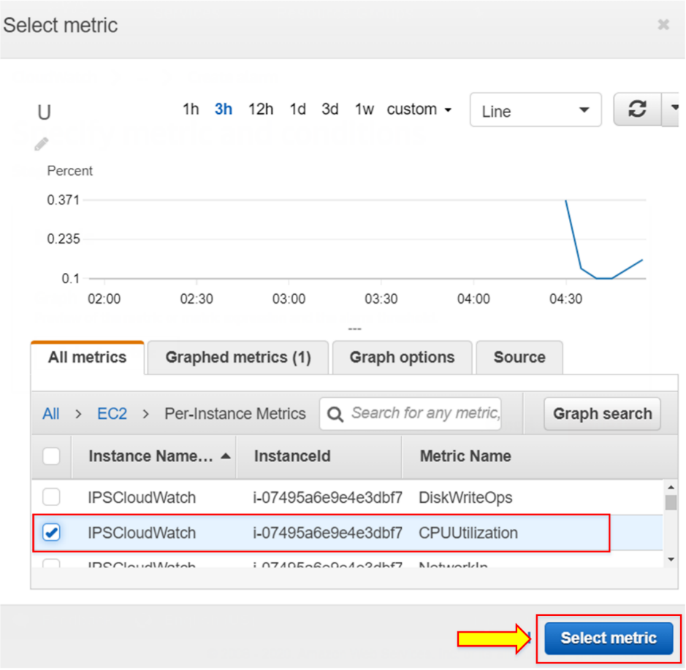

**Note:** Click the implemented instance ID that you have entered and select the CPU Utilization.

1. Set the threshold value of your need, like 60. Then, click on **Next**.

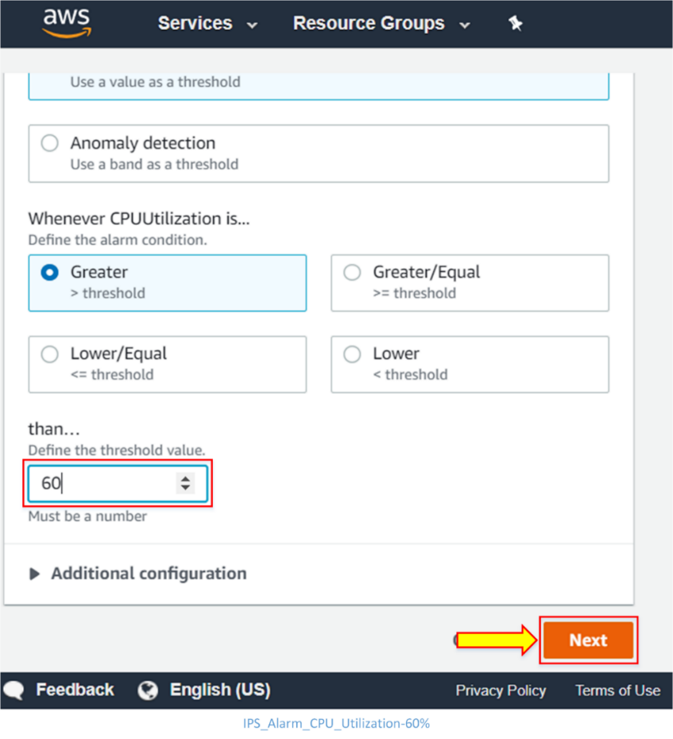

**Note:** Whenever the CPU utilization goes greater than 60%, it will send an alarm.

1. Write the name of the alarm **IPS_alarm**, and enter your email address in the given space.

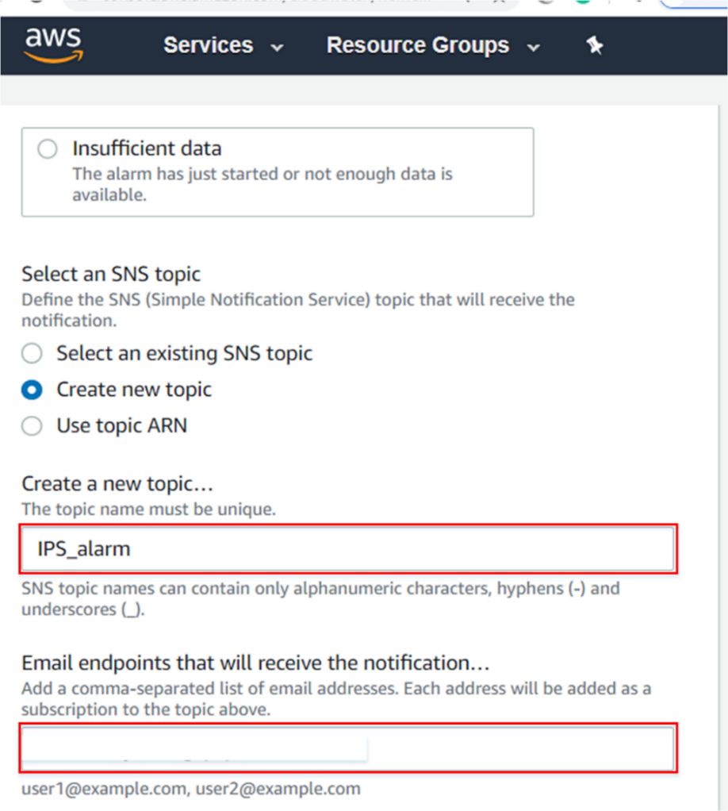

**Note:** The notification of alarm will be received via email at the address you have entered.

1. Click on **Next**.

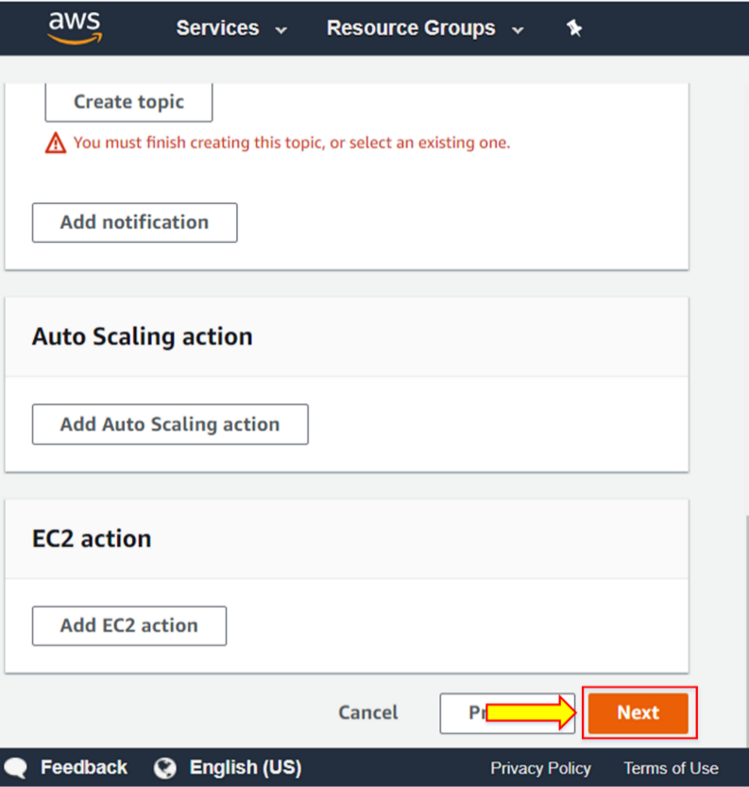

1. Enter the name of the alarm and alarm description. Click on **Next**.

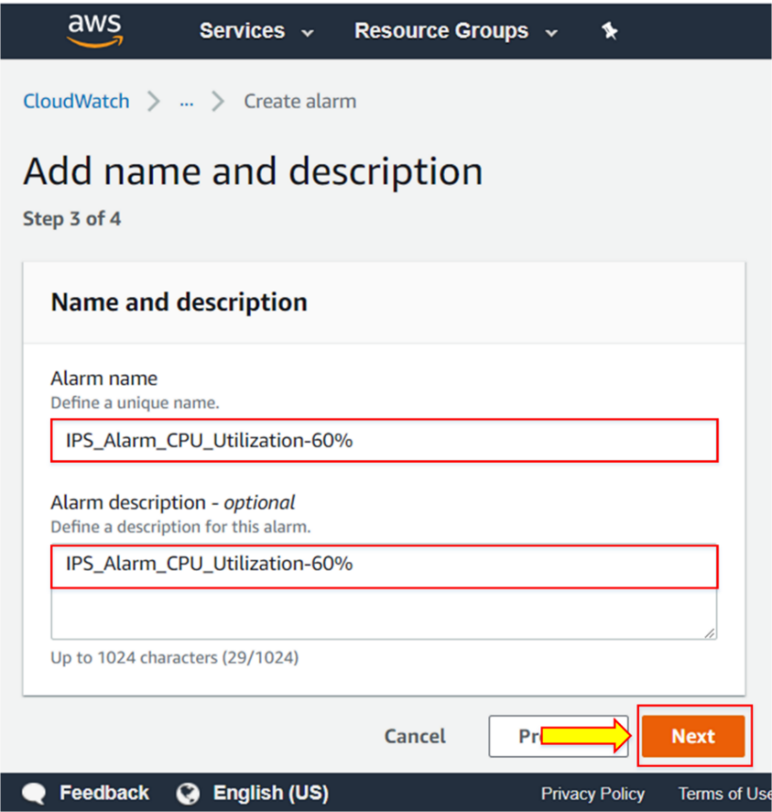

1. Click on **Create alarm**.

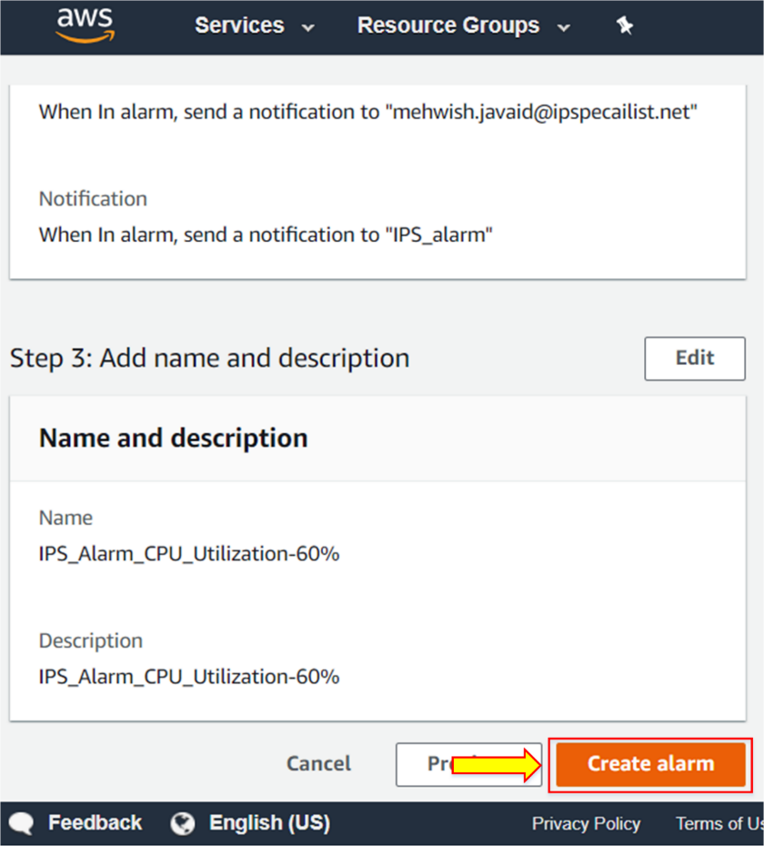

1. You will receive a notification saying **Subscription confirmed!** at the registered email address.

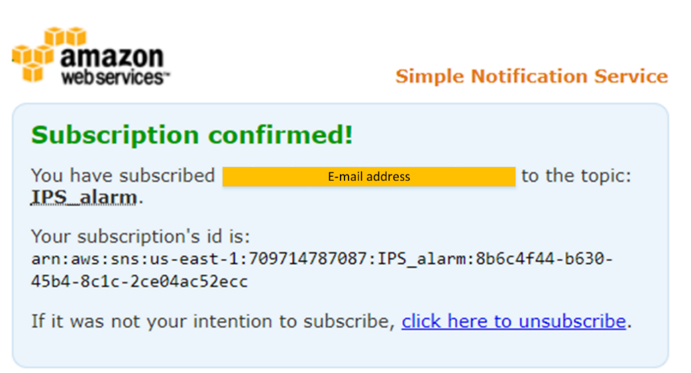

1. Go to the **Service**, click on **EC2**.

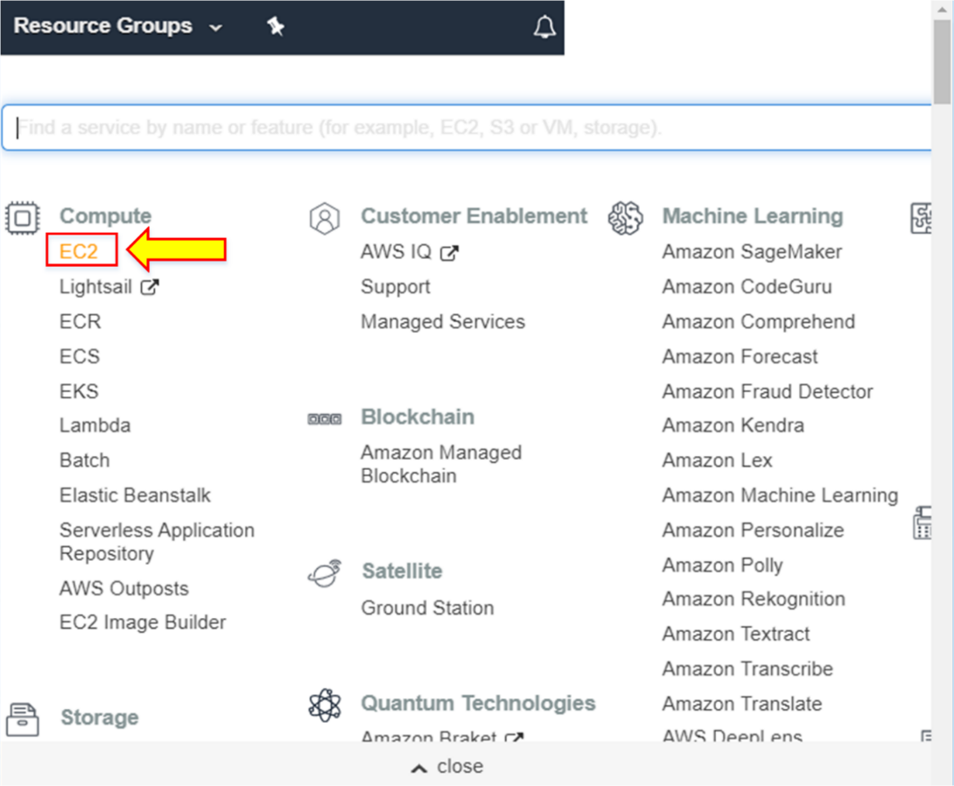

1. Click on the **Running instance**.

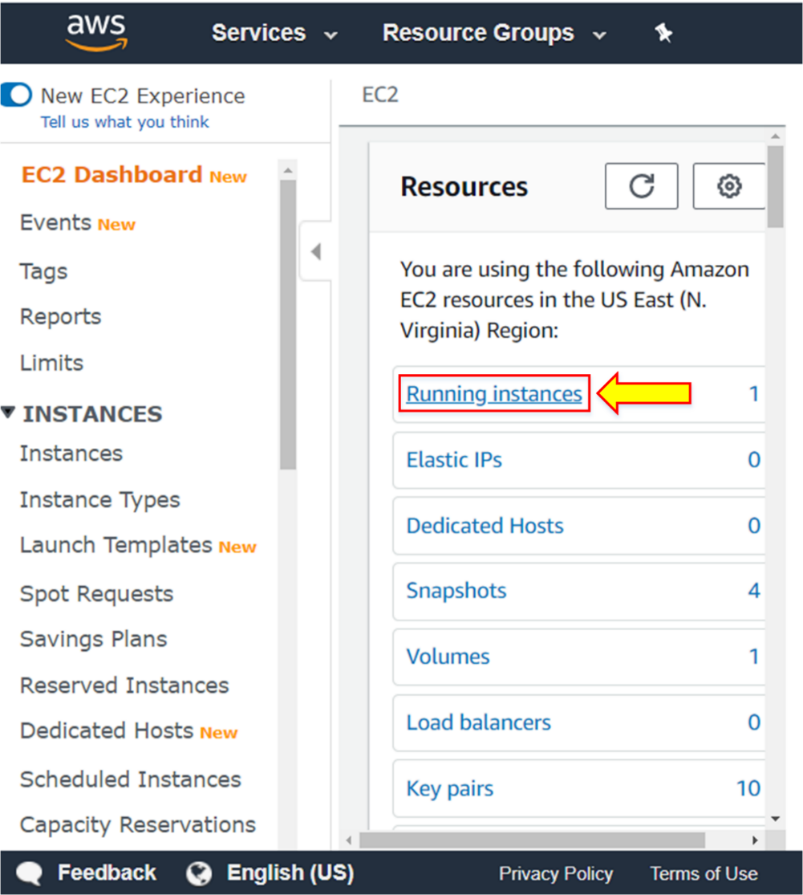

1. Click on **Connect** to connect to SSH.

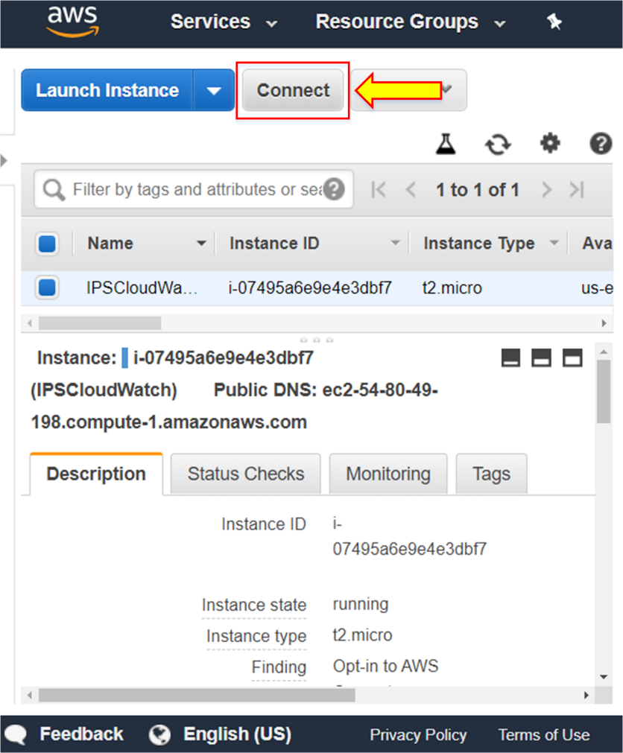

1. Select **EC2 Instance Connect** (browser-based SSH connection).
2. Write the user name of **ec2-user**. Click on **Connect**.

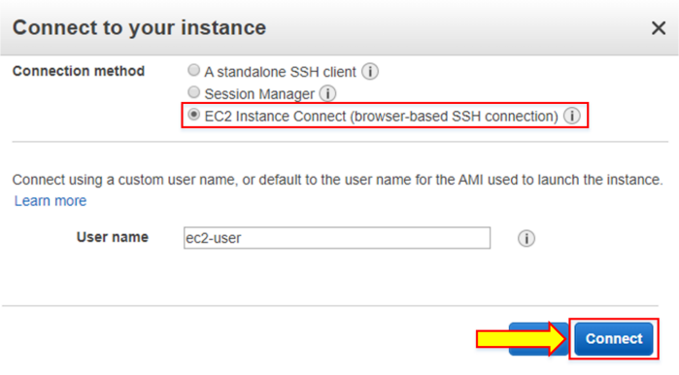

**Note**: You can also connect to SSH by using PuTTY.

1. To connect to SSH by using PuTTY, open PuTTY from the search bar in the left corner of the desktop.
2. Copy the IP address of the running instance.

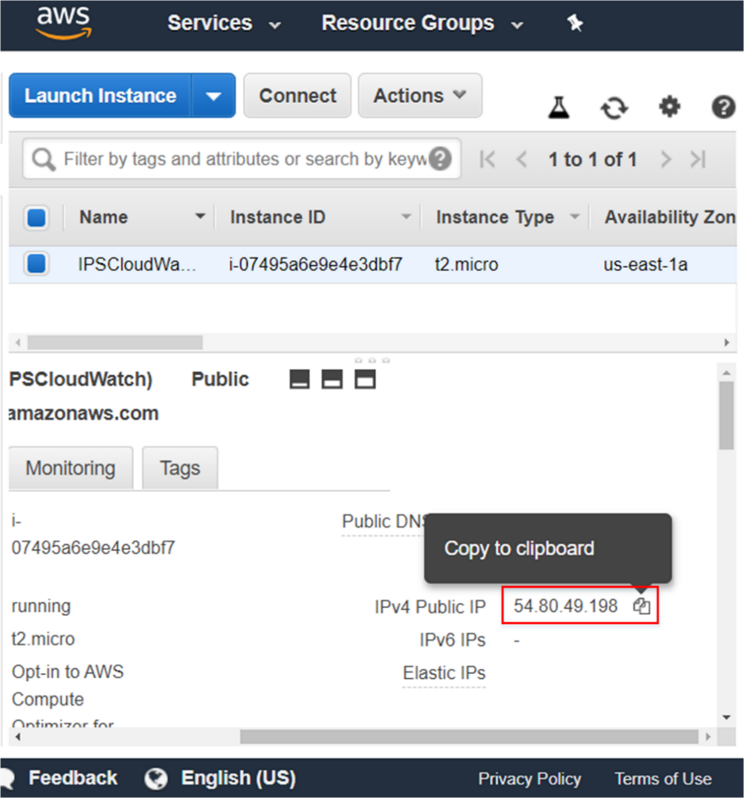

1. In PuTTY, click on **SSH**, and go to the **Auth**.

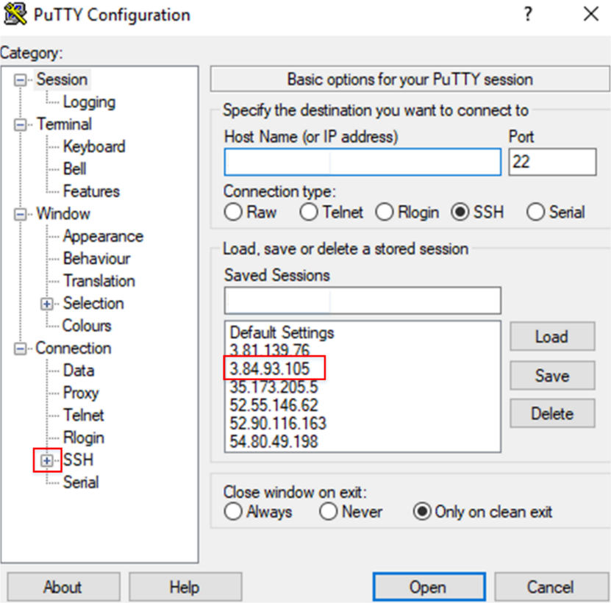

1. Browse the location of the downloaded **key pair name** and click on **Open**.

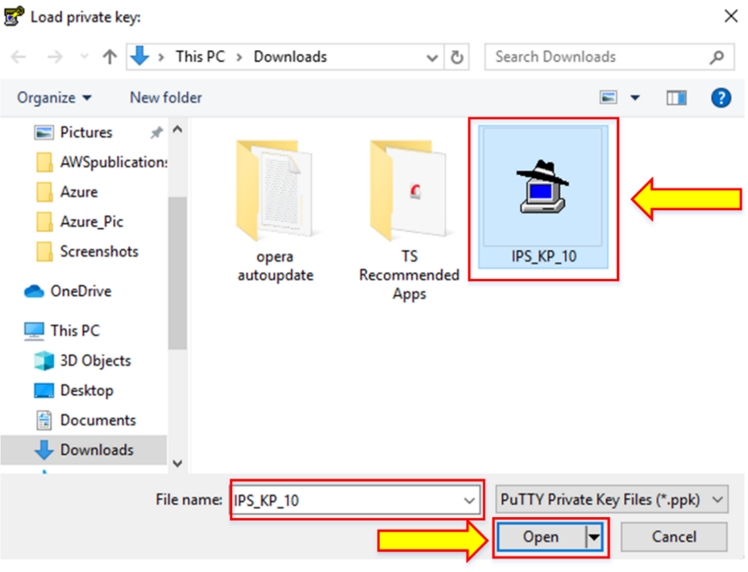

1. Click on **Open**.

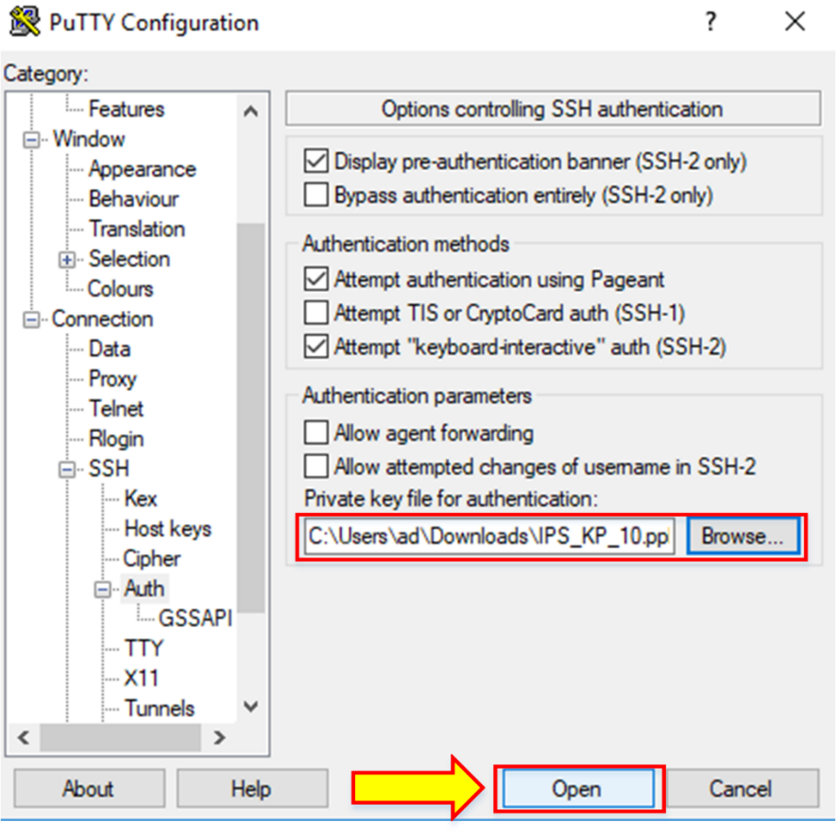

1. Go to the **Session** and load the IP address of the running instance.

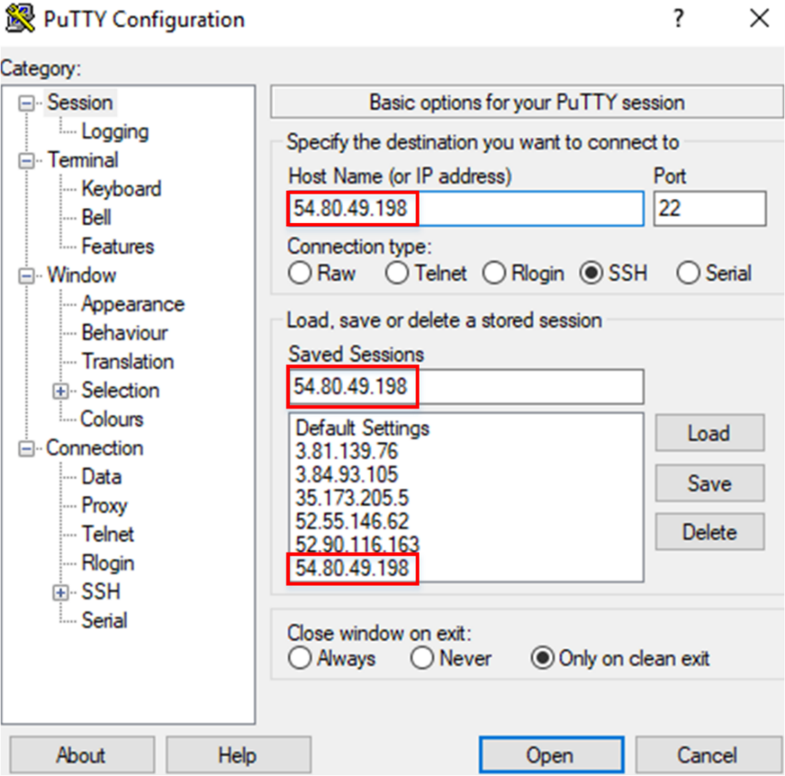

1. Log in as **ec2-user**.
2. Write **sudo su**.

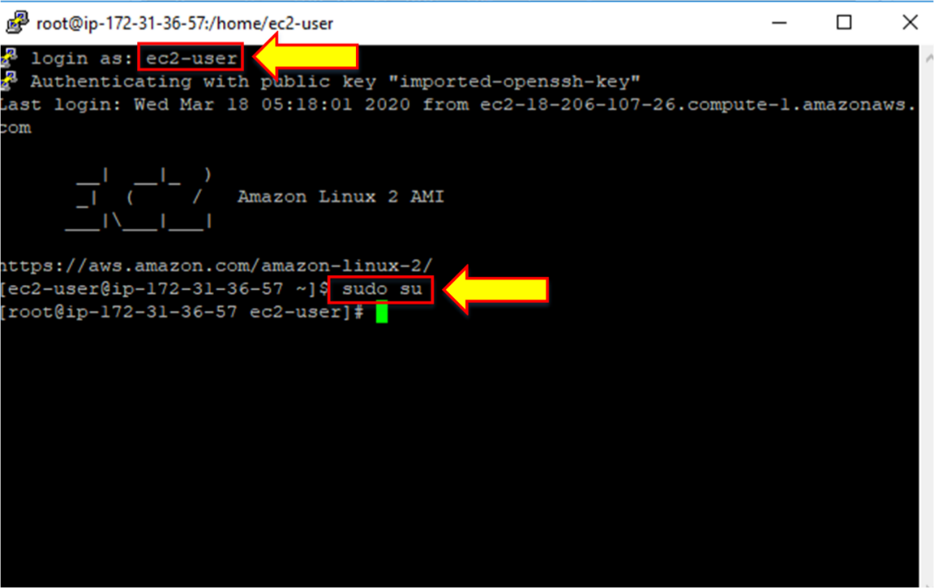

1. Write **clear**.

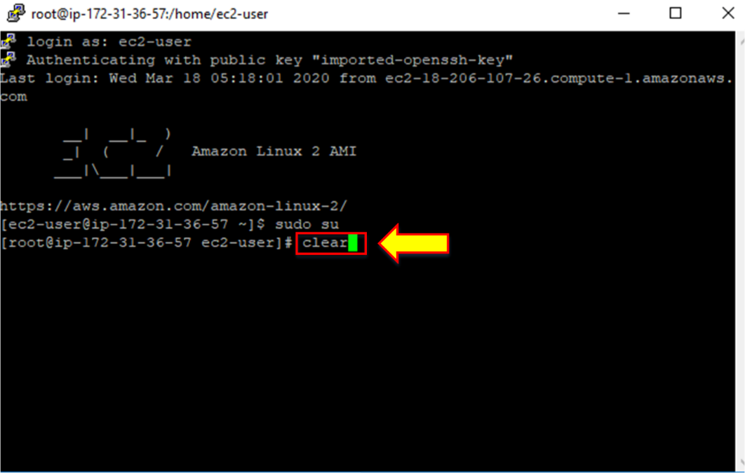

1. Write **while true; do echo; done**.

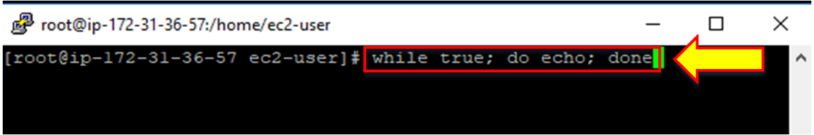

1. After some time, the notification of the alarm will be sent to your entered email address.

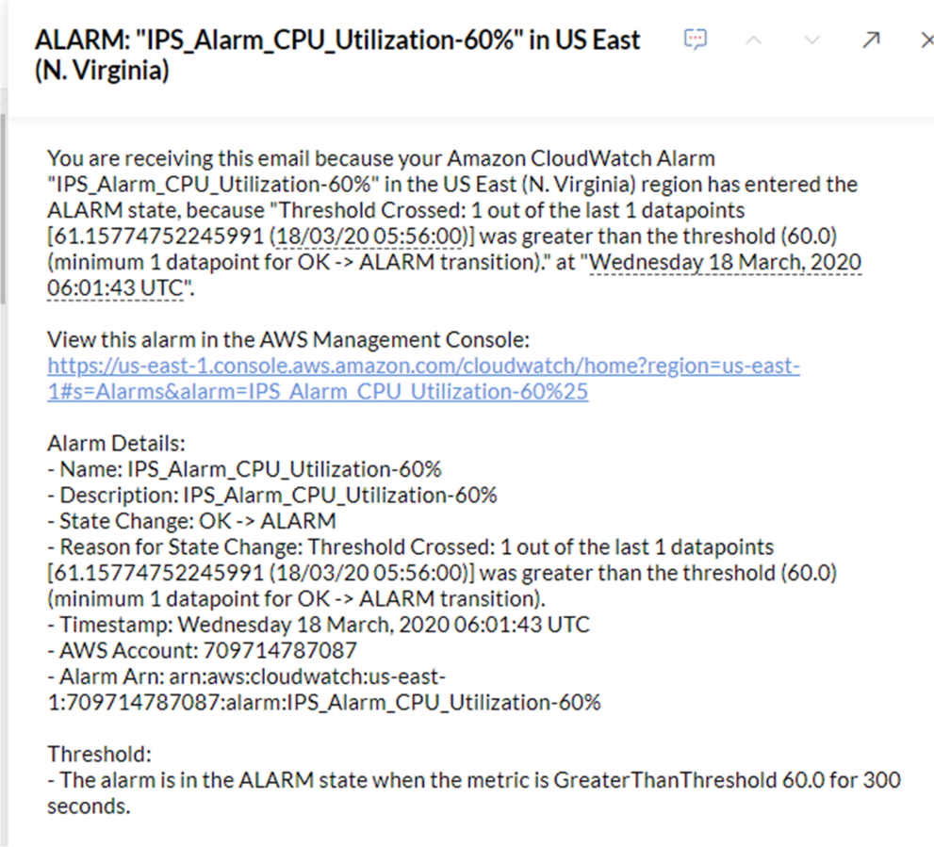

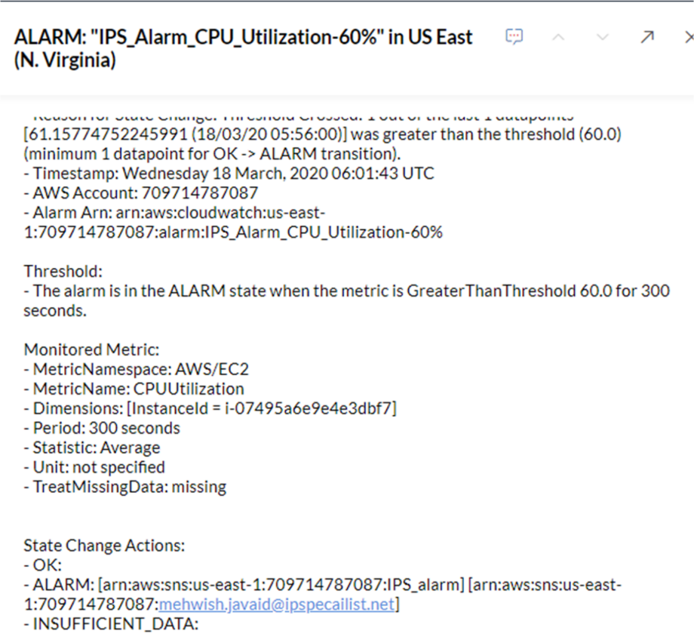

1. To check the cloudwatch alarm, go to the **CloudWatch** section.

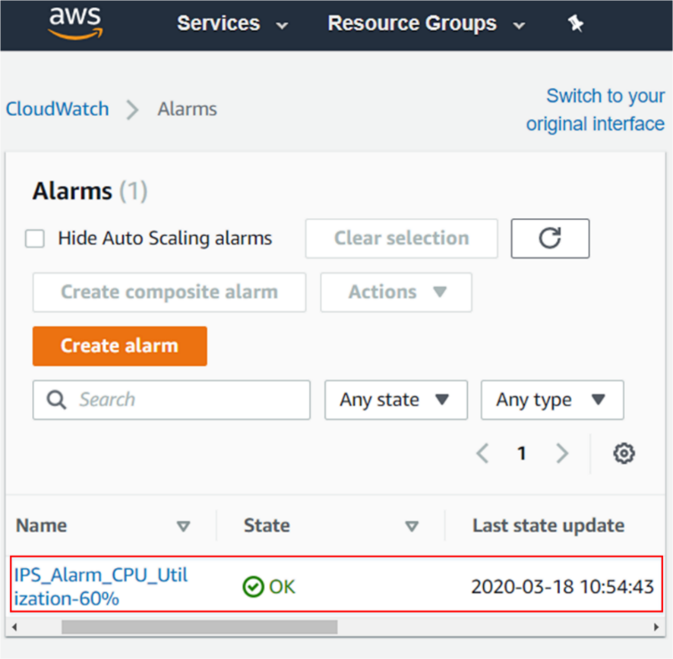

1. To check the CPU utilization, click on the **Monitoring** tab present in EC2 instance.

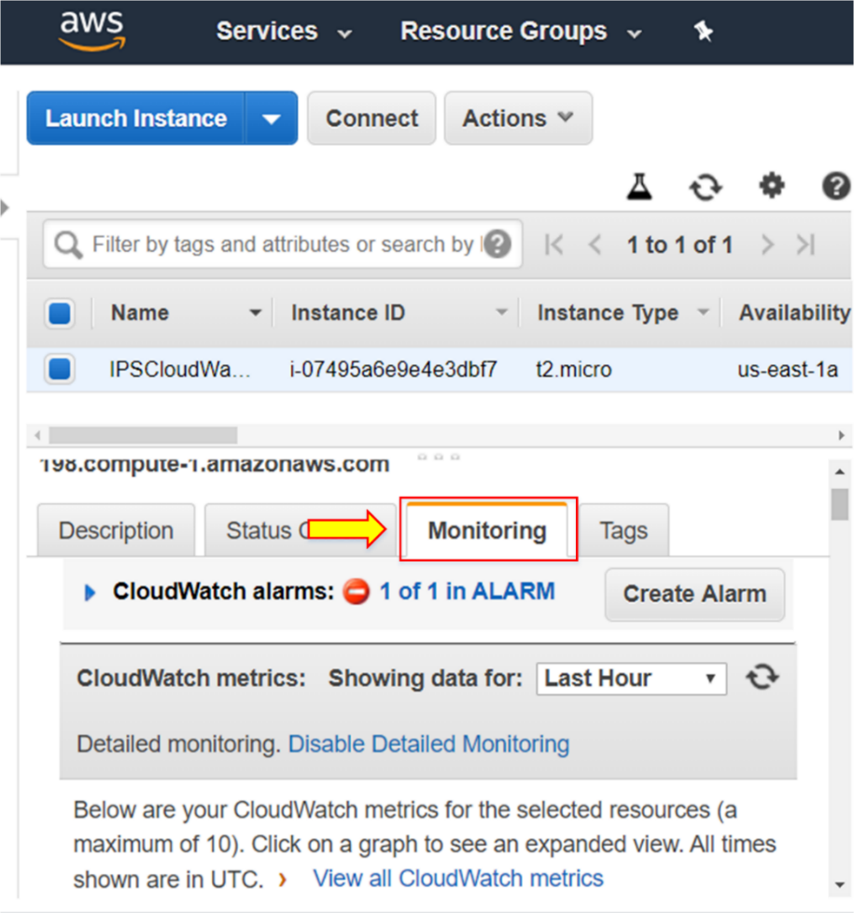

1. You will see the CPU utilization.

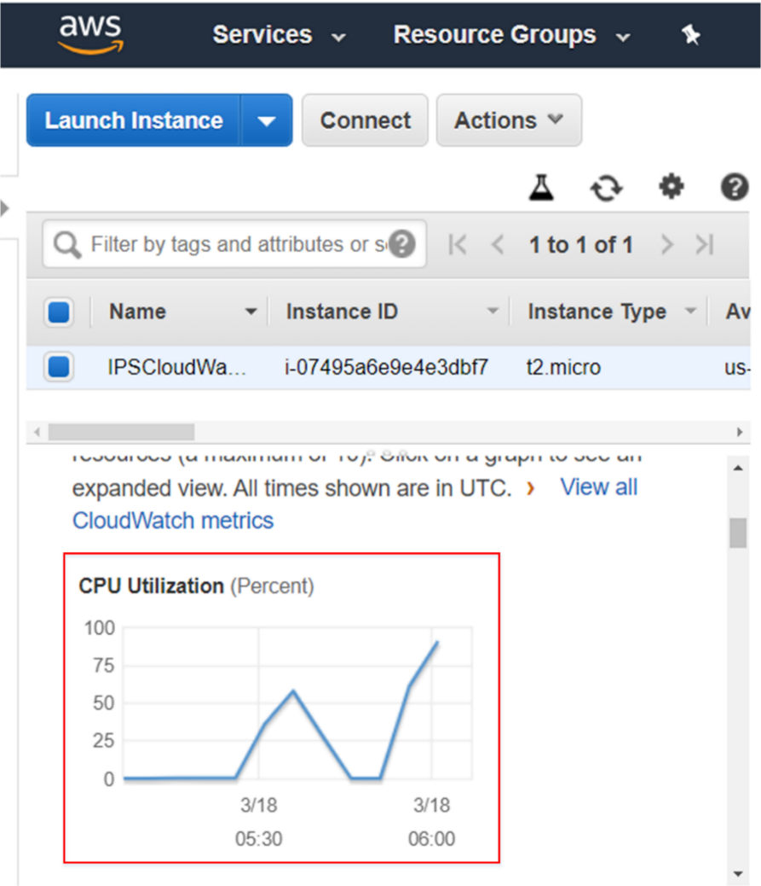

1. To check the state, go to the **CloudWatch** present under **Management and Governance**.

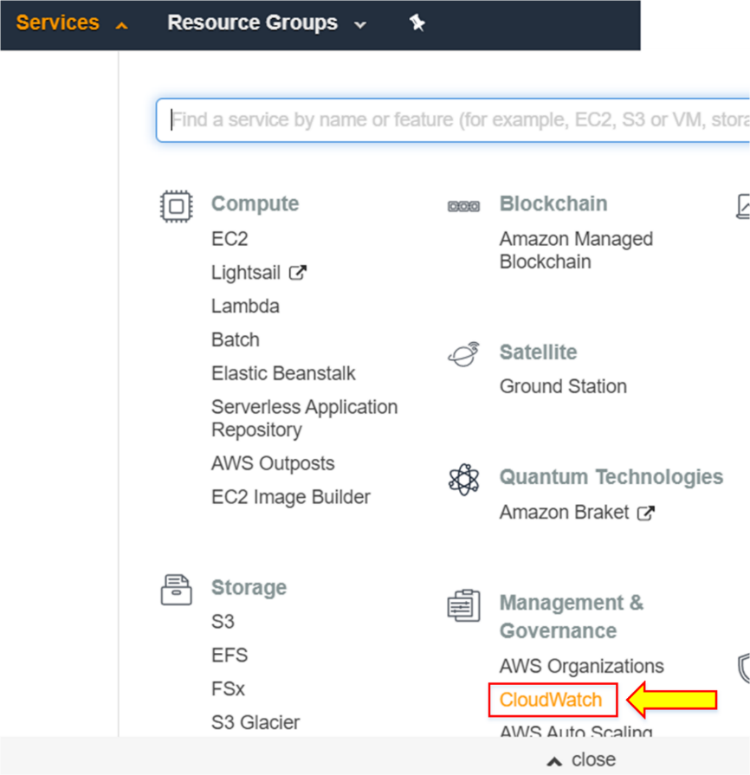

1. You will see the **Alarm** has now been triggered.

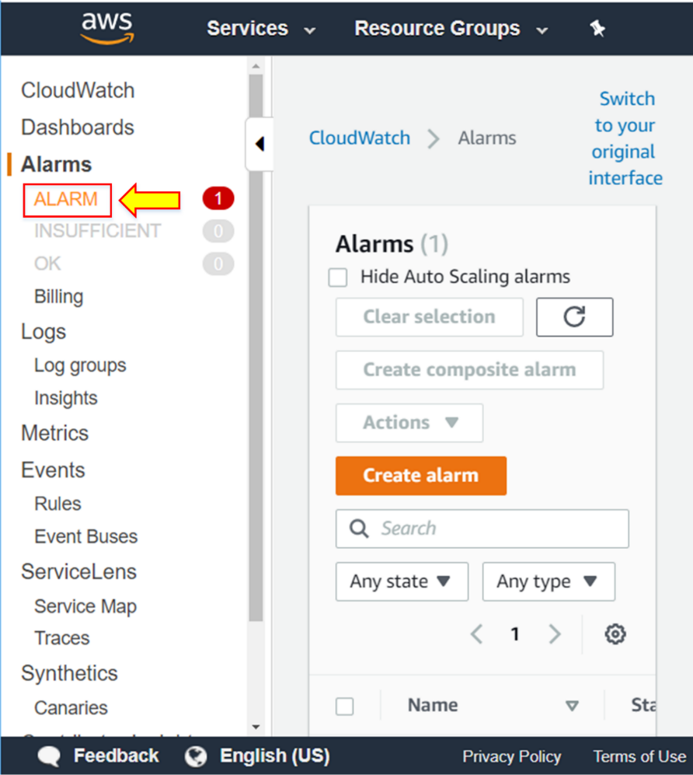

1. Click on **Dashboards**.

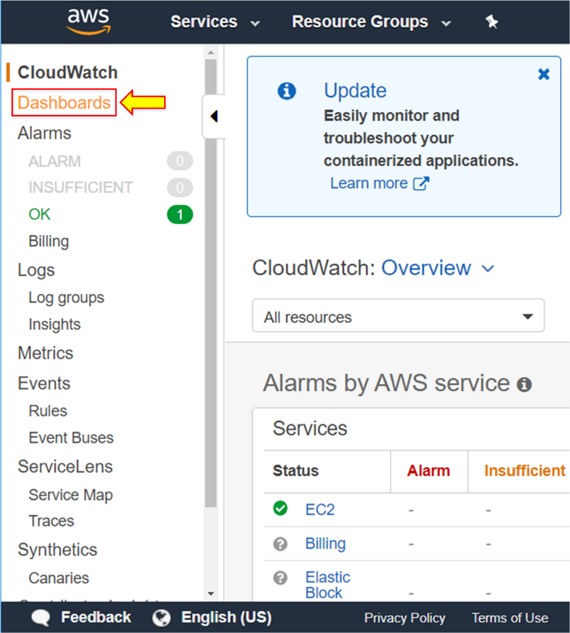

1. Click on **Create dashboard**.

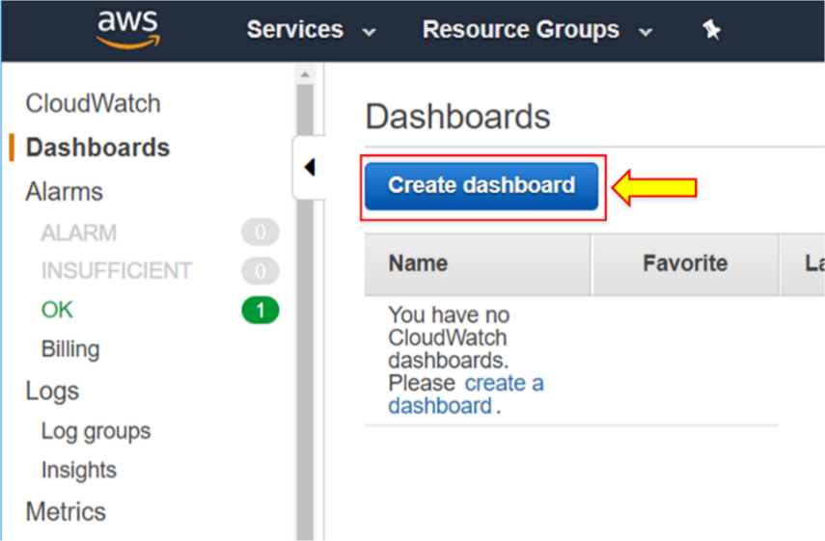

**Note:** You can create a dashboard to show the region or to give a global overview.

1. Click on **Cancel**.

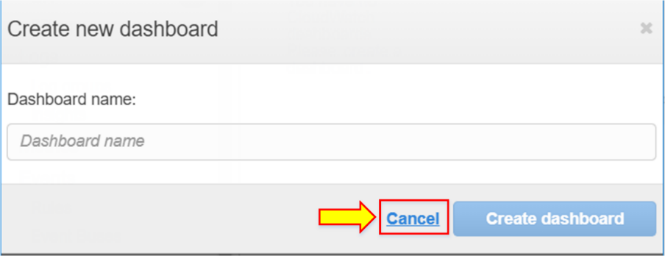

1. Click on **Logs**.

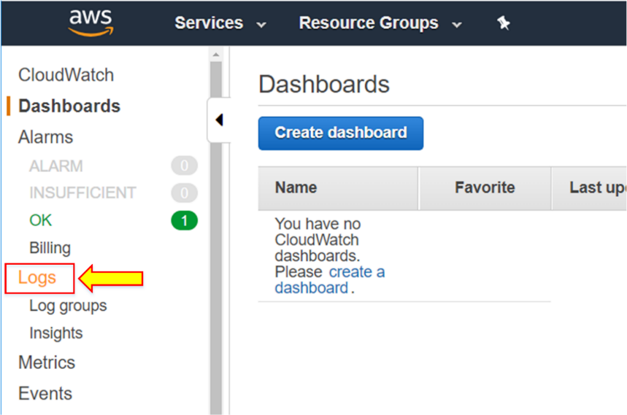

1. You will see the different options available.

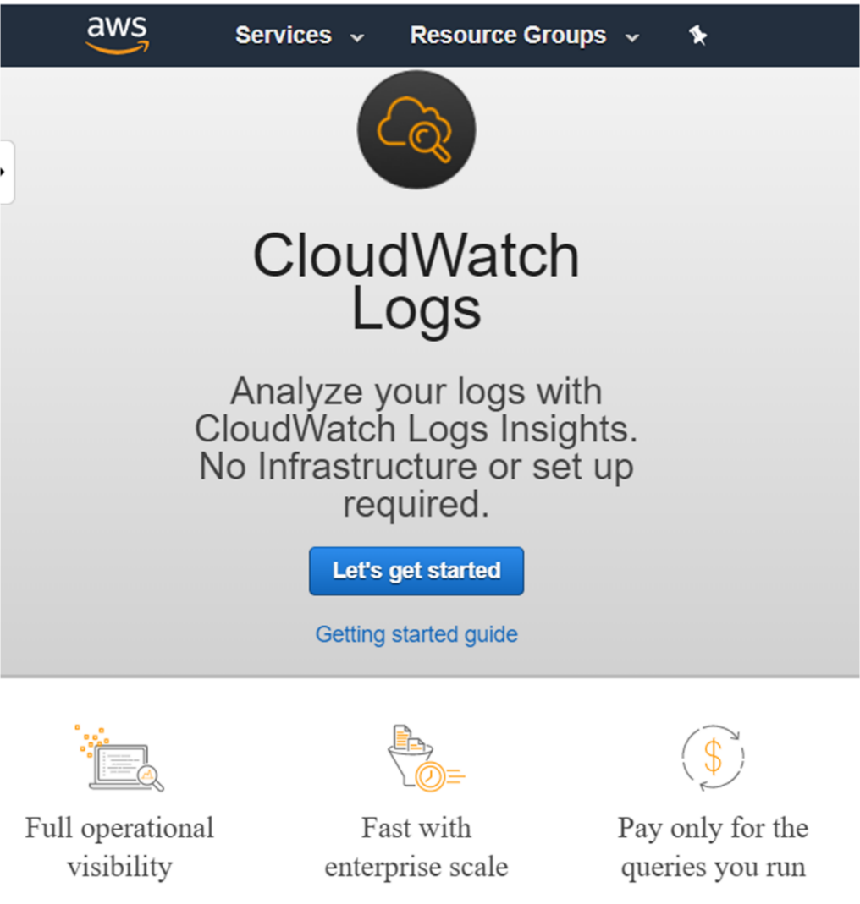

**Note:** Logs allow us to do performance logging. You can send logs to CloudWatch.

1. Click on **Events** from the left menu.

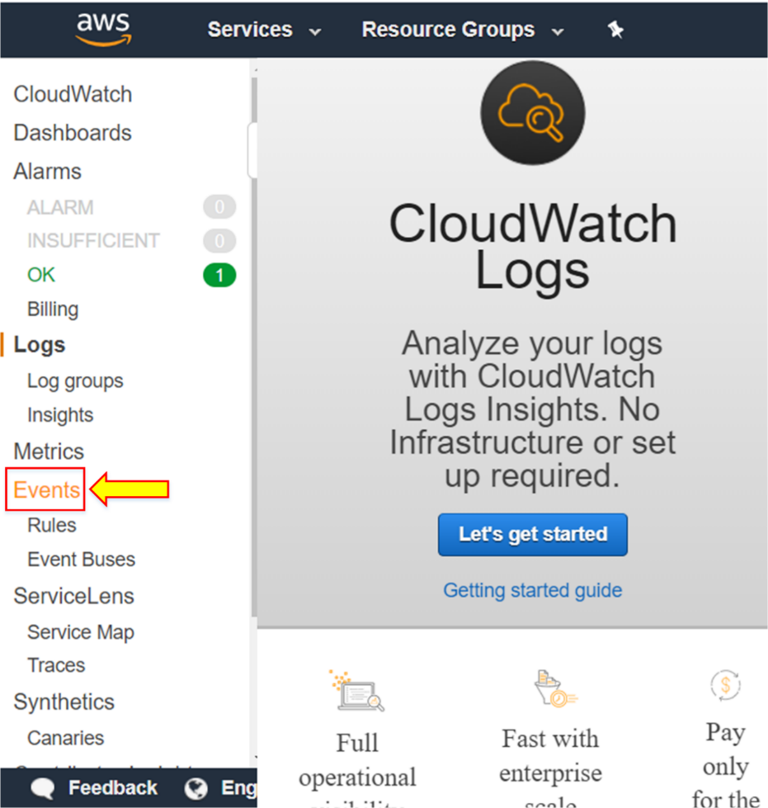

1. The **Amazon CloudWatch Events** page will open up.

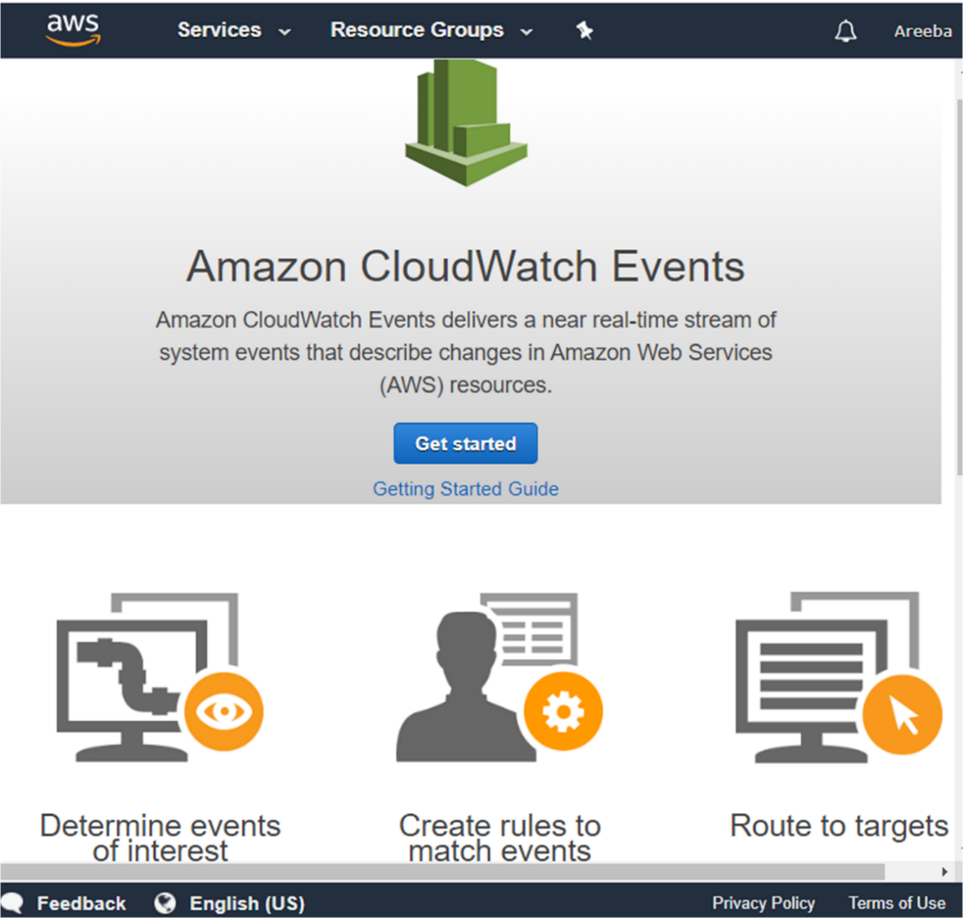

**Note:** CloudWatch Events delivers a near real-time stream of system events that describe changes in AWS resources.

1. You can go inside by clicking **Get started**, and create some events if you want.

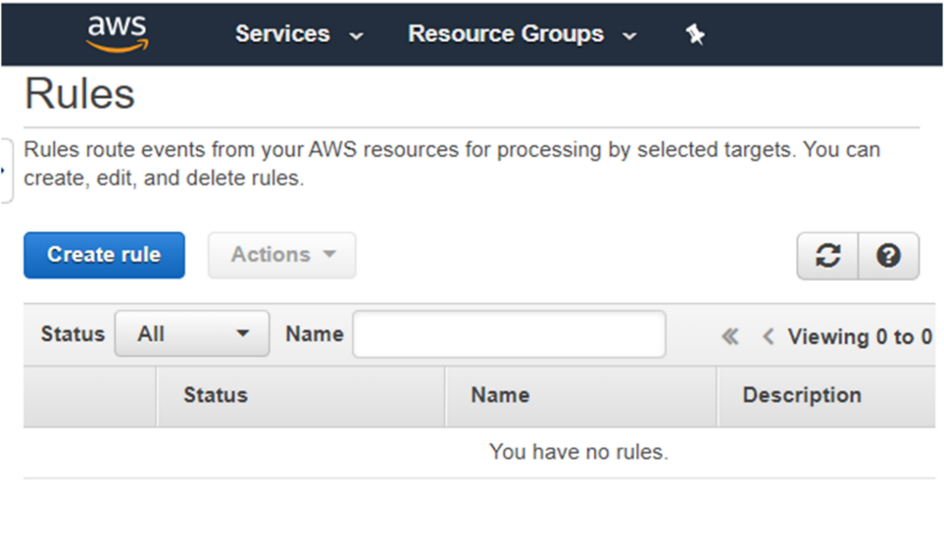

**Lab 03: GCP Billing and Cost Management**

**Case Study**

Spotify is a global audio streaming platform that delivers music and podcasts to hundreds of millions of users worldwide. To support large-scale data analytics, content delivery, recommendation engines, and backend services, Spotify relies extensively on Google Cloud Platform (GCP). Its cloud environment spans multiple projects and services, generating significant daily usage and billing data.

As Spotify continues to scale its platform and expand its services, effective cloud cost governance becomes a critical operational requirement. Engineering teams frequently deploy and scale resources dynamically, making it essential to maintain clear visibility into usage patterns and spending trends across projects.

To achieve financial transparency and maintain cost efficiency, Spotify uses Google Cloud’s native billing and cost management capabilities, specifically Billing Export to BigQuery and Budgets and Alerts, to monitor, analyze, and control cloud expenditure in real-time.

**Business Challenge**

Operating at a global scale, Spotify generates large volumes of cloud usage data across compute, storage, analytics, and machine learning services. Without centralized billing visibility, it becomes difficult to track daily costs, identify inefficient resource consumption, or attribute spending to individual teams and projects.

Additionally, unmonitored cost growth can result in unexpected budget overruns, impacting financial planning and operational efficiency. Manual monitoring approaches are insufficient in a fast-changing cloud environment, and delayed notifications reduce the ability to take corrective action in time.

Spotify required an automated, scalable mechanism to export billing data for detailed analysis and to receive proactive alerts when spending exceeded predefined thresholds.

**Solution**

To address these challenges, Spotify uses GCP Billing Export to continuously export detailed billing and usage data into BigQuery, where it can be queried for cost analysis, forecasting, and optimization. This enables granular insights into spending by service, project, and time period.

In parallel, GCP Budgets and Alerts are configured to notify billing administrators and stakeholders when costs approach or exceed defined limits. These alerts allow teams to take timely action, such as optimizing workloads or adjusting resource configurations, before costs escalate.

This combined approach ensures financial accountability, proactive governance, and efficient cost management across Spotify’s Google Cloud environment.

In this lab, you will perform hands-on tasks to mirror these real-world practices:

* Export billing data to BigQuery for detailed cost analysis and reporting
* Set up billing alerts to monitor and manage cloud expenditures proactively

**Task 1: Export Billing Data to BigQuery**

|  |
| --- |
| Now, the organization wants to export daily usage and cost estimates to monitor, analyze, and optimize cloud spending. Follow these steps to complete the lab tasks.  1. Log in to the console with the administrator account.  2. Set up and export billing information in this lab.  3. Open the Navigation Pane and click on **Billing**.    4. Click on the **Billing export**.    5. Click on **Edit Settings**.    6. To create a data set in BigQuery, we could follow the link named **Go to BigQuery**.    7. The dataset resides inside the project. In GCP, to avoid mixing all of the stuff, we use Projects to manage GCP resources.  8. Let’s create our first new project.  9. Open up the navigation menu and click on **Home**.    10. Create a **New Project**.    11. Provide your project with a specific name.    12. Remember that the name of the project is not globally unique, but the project ID and project number are globally unique.  13. Provide a specific name and click on **Create**.    14. We can create a project, and a new notification will appear on your screen.    15. Inside the **Admin Project**, let us select the BigQuery service to export the billing dataset.  16. Select the **BigQuery** service. Select your project.    17. Click on **Hide Editor**.    18. Click on **Create Dataset**.    19. Provide a name for your dataset, a location, and a specific date of expiration as well.  20. Create a **dataset**.    21. The data set is created. Inside the dataset, you can also add the description and expiration date.  22. We can add labels to the dataset.        23. Now, you can see how Google displays labels.    24. Let us go back to the **Billing** section and select **Billing export**.  25. Edit **Settings**. Choose your **Admin Project**.  26. Edit the billing setting.    27. Now, the billing export using BigQuery is enabled. |

**Task 2: Set up Billing Alerts**

|  |
| --- |
| Now, the organization also wants to receive notifications when cloud spending exceeds defined thresholds. This ensures timely action to prevent budget overruns.  1. Log in to GCP Console with the Administrative Account.  2. Go to the Navigation Menu and select **Billing**.    3. In the Billing Menu, choose **Budgets & alerts**.    4. Select **Create Budget**.    5. Provide a specific name for your budget.  6. Make sure to select your billing account.  7. Set the **Budget** amount.    8. Optionally, you can choose Cost after credit. After the credit, the total cost minus any applicable credit(s). Credits may include usage discounts, promotions, and grants to use the Google Cloud Platform.  9. **Save** the settings.    10. The budget is created.    11. You can see a little thermometer here, which represents the budget utilization. |